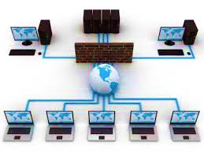

Warren Hood
Eshowe high school
cat grade 10
The role of a network in the computer world
Focus: personal area networks
presented: 29 july 2016
Contents Page
Cover 1
Contents 2
Task Definition 3
Focus Question 4
Investigation 5-8
Questionnaire 9
Screenshots 10
Declaration of authenticity 11

Task definition
Purpose of this investigation:
The purpose of this investigation is to learn more about the role of computer networks in the computer world and their uses. I will then present my findings to the learners in my school in order to inform them more about the role of networks.
Focus of this investigation:
The focus of this investigation will be on computer networks, but more specifically on Personal Area Networks (PAN), on which my focus question is.
How I will approach the task:
I will create a questionnaire and administer it to my entire school via email. I will conduct research using the internet as a source, another possible source could be books. Afterwards I will analyse my survey results in a spreadsheet. Then in phase 3 I will present my findings using PowerPoint.
My target audience:
My target audience will be the learners in my school and possibly some of the teachers from my school.
How I will present my findings:
I will present all of my findings (or at least a summary of it) using a PowerPoint presentation during phase 3 of this investigation.

Focus Question

Headings
Uses of networks
Types of networks
Networks
Physical components of a network
Types of connections in a network
Investigation
Heading: Types of networks__________________________________________
No | Question | Possible source
1 | What are the different types of networks? | Internet
2 | What are some advantages of networks? | C.A.T. TEXTBOOK
3 | What are some disadvantages of the different types of networks? | INTERNET
Heading: Uses of networks____________________________________________
No | Question | Possible source
1 | What are the different uses of networks? | INTERNET
2 | What is the most common use of a network? | INTERNET
3 | Where are networks used mainly? | PEOPLE
Heading: Physical components of a network_______________________________
No | Question | Possible source
1 | What are the different components of a network? | TECHNICIAN OR INTERNET
2 | What is the cost of the setting up a network? | C.A.T. TEXTBOOK OR INTERNET
3 | Is it necessary to purchase anything in order to set up a basic network? | INTERNET
Heading: Types of connections in a network____________________
No | Question | Possible source
1 | What are the different types of connections used in networks? | C.A.T. TEXTBOOK
2 | What is the most commonly used type of connection used in a network? | INTERNET

Source 1 | Internet
Name of website | Kingofnetworking.weebly.com
Name of web page | different-types-of-computer-networks.html
URL | http://kingofnetworking.weebly.com/different-types-of-computer-networks.html
Author | King Of Networking
Date created/updated | July 24, 2011
Date accessed | September 10, 2016
Summary of source information
The different types of networks can be classified according to the way they transport data, their scale etc.
Some types of networks are:
- Local Area Networks(LAN)
- Metropolitan Area Networks(MAN)
- Wide Area Networks(WAN)
- Personal Area Networks(PAN)
- Campus Area Networks(CAN)
- Home Area Networks(HAN)
- Storage Area Network(SAN)
- Desk Area Network(DAN)
- Virtual Private Network(VPN)
The internet itself is a computer network. It is actually the biggest WAN ever created. The internet is basically a network that connects a whole lot of smaller networks across the world.
A diagram of a Wide Area Network 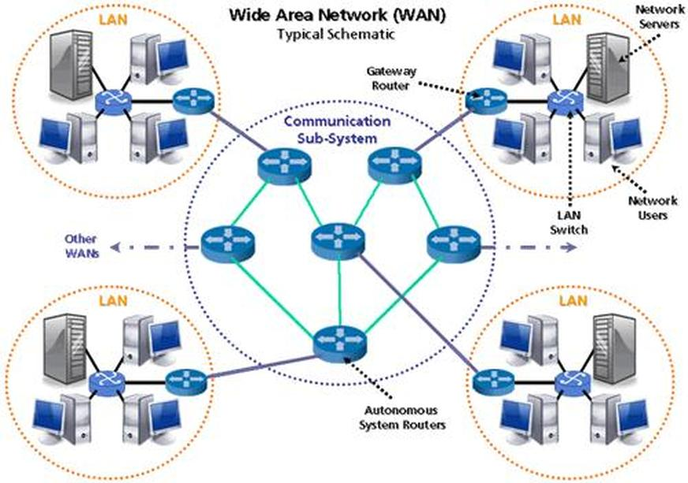

Source 2 | Internet
Name of website | Ecomputernotes.com
Name of web page | What-is-a-computer-network
URL | http://ecomputernotes.com/computernetworkingnotes/computer-network/what-is-a-computer-network
Author | Dinesh Thakur
Date created/updated | May 7, 2013
Date accessed | September 13, 2016
Summary of source information
The reasons that computer networks are used are:
- To share resources
- To provide high reliability
- Help people to save money
- Provide a medium of communication between connected devices.
A diagram of how a printer is used in a network is shown below: 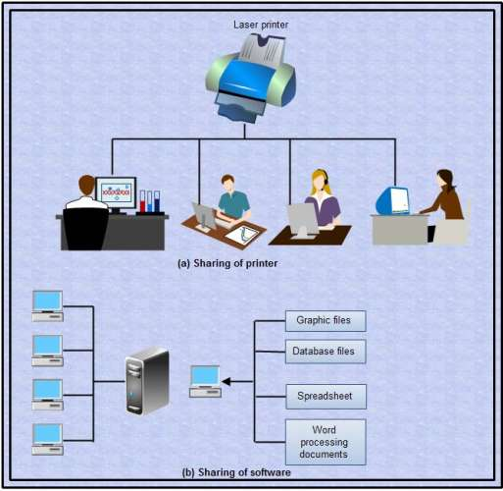

Source 3 | C.A.T TEXTBOOK
Title of book/magazine | Computers, Part of your life
Article name/chapter/pages | Network basics Module2.2 pg. 106-109
Authors | Sandra Jacobs, Reinet Barnard, Keith Gibson, Ellen Labuschagne, Pam Macmillan, Pam Miller, Chris Noomé, Karin Stoffberg and Ulza Wassermann
Date published/issued | September 2011
Publisher | Study Opportunities
URL [only for electronic media such as articles uploaded to the web (electronic documents)] | N/A
Summary of source information
There are two ways that computers can be connected in a network. I.e. cabled or wirelessly.
Cabled connections involve the use of UTP cables to connect all the devices and computers that are in the network. A common example is a PAN that involves a device being connected to a computer using a USB cable.
Wireless connections involve the use of a router or modem and a wireless-enabled device. A common example is WLAN (Wi-Fi) or even Bluetooth used by cell phones and portable devices.

Computer Networks Questionnaire
Name
Age
Gender | Choose an item.
Date | Click here to enter a date.

Kindly answer the questions below as honestly as possible
1. | Do you use a computer network?
2. | Are you aware of what a computer network is?
3. | What, in your opinion, is the biggest advantage of a Personal Area Network?
 |  | Choose an item.
4. | What, in your opinion, is the biggest disadvantage of a Personal Area Network?
 |  | Choose an item.
5. | What do you use computer networks for?
 |  | Choose an item.
6. | Do you find networks useful?

Thank you

Screenshots of folder structure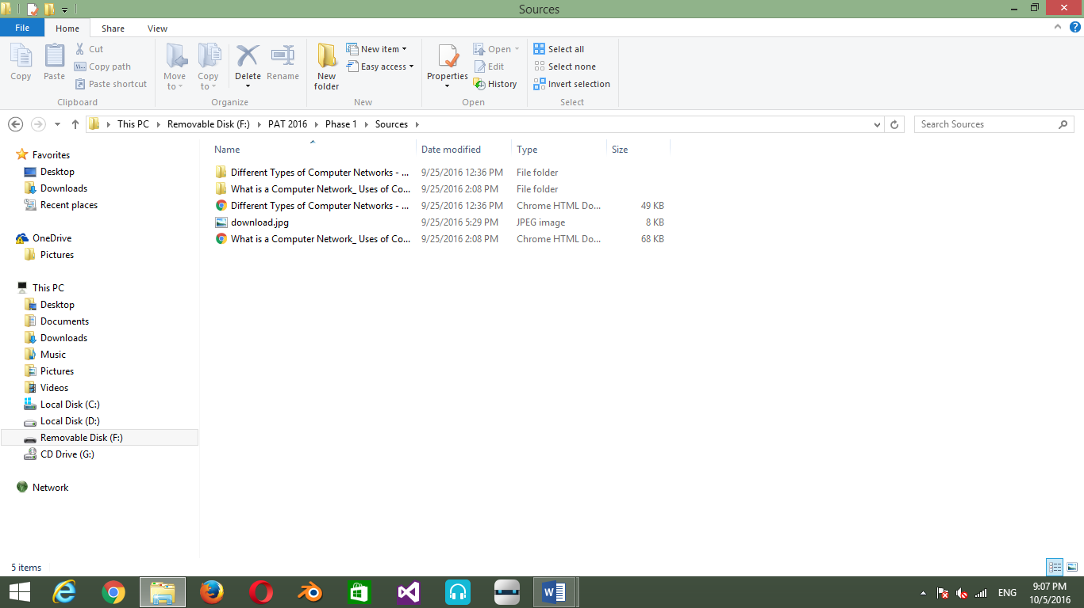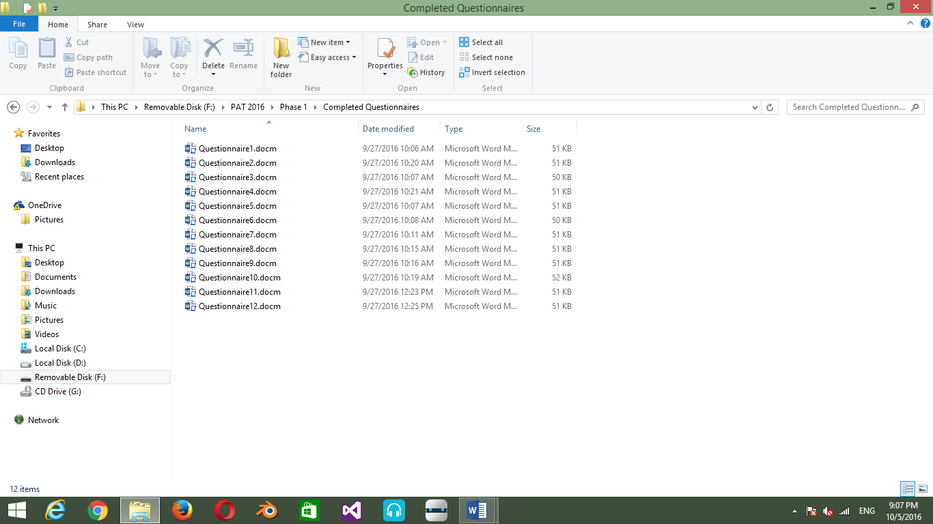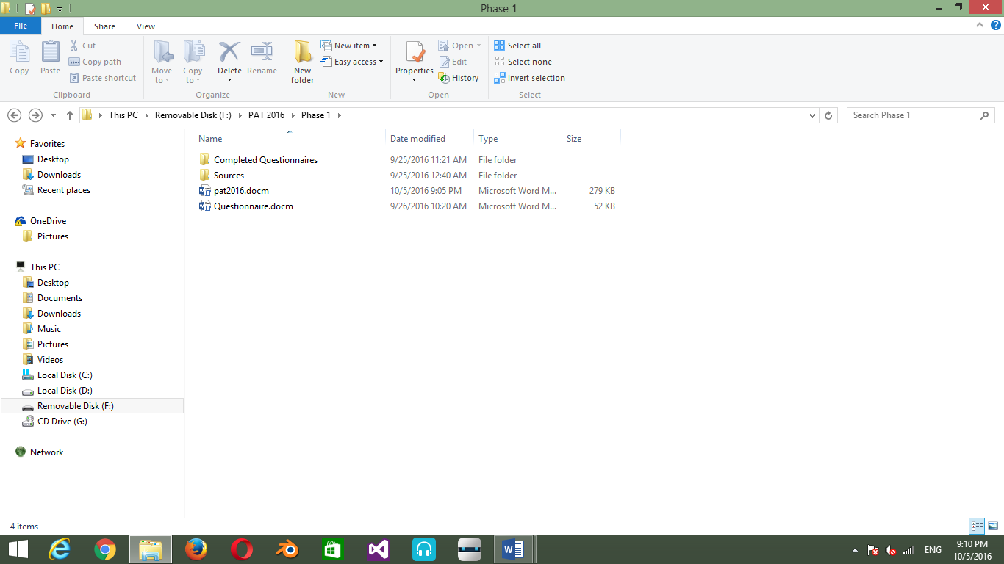

Declaration of authenticity

Learner declaration – Phase __1__
I understand that work submitted for assessment must be my own.
Did you receive help/information from anyone to complete this work/project?
No Yes (provide details below)
Help/information received from (person): | Nature of the help/information (provide evidence):
I hereby declare that the contents of this assessment task are my own original work (except where there is clear acknowledgement and appropriate reference to the work of others) and that I have not plagiarised, copied from someone else or used work previously submitted for assessment by anyone else.

_________________________ _23__ / __9_ / 2016
Signature of Learner Date

